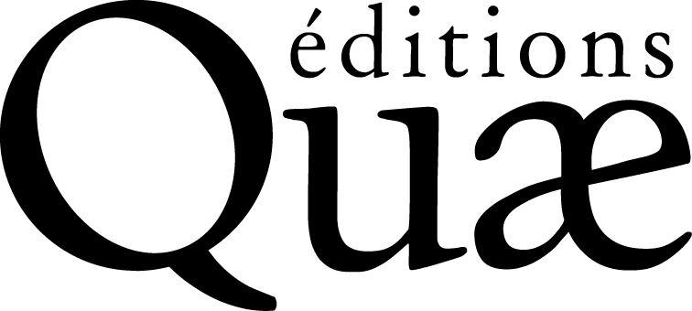
Publication Request

Please send via email to : bureaueditorial@quae.fr
Or by regular mail to following address: Bureau éditorial Quæ, c/o Inra, RD 10, 78026 Versailles Cedex
For any information, tel.: 01 30 83 35 48, fax: 01 30 83 34 49

Working title of the book

1. Content of the project
Author(s) or Coordinator(s)
Last name, first name, titles and positions, employing organization, address, phone number, fax number, email address (professional and private)
(Please attach a short resume and a list of your most significant publications of the last three years)
Thematics:
Which audience is your book primarily targeting? Why?
(If you fail to answer this section, your publication request will not be examined)
State of progress of your work
Project Drafting stage Manuscript completed
Timeline
Deadline for manuscript submission:
Strict deadline for publication, where appropriate (in case of a scientific event for instance):
In case of a specific publication date, the éditions Quae will decide on a strict deadline for manuscript submission with the authors; failing to comply with this deadline may result in the postponement or the cancellation of the publication.
Subject and plan of the book (please insert the detailed subject and plan at the end of this application form)
Subject: please summarize in about thirty lines the subject of the book, specifying your goals, the originality of your work, as well as the book’s estimated lifespan. Provide a rationale in favor of your project.
Plan: please attach as detailed a plan as possible, indicating the number of pages for each chapter (for instance, one printed page includes approximately 2 900 signs, including spaces). If you are the book’s coordinator, please indicate the names and affiliation of the authors you have contacted and whether they have accepted to collaborate.
Competition
What French or foreign books deal in part or entirely with the same subject?
What books might YOU have already published on that same subject (please include both the youngest and oldest publications)?
For each of them, indicate the authors’ names, the title, the name of the publisher, the year of publication, the number of pages and, if possible, the sales price.
How is your current project different from the previous ones?

Has this book been written in collaboration with other organizations?
Please specify which ones:
Has your project already been published or distributed? In what form? How many copies? On what terms, for free or for a fee?
Reading Committee
Every project will be submitted to a reading committee.
Please indicate, if possible, potential readers likely to critically assess your manuscript (one reader per type of audience targeted): family name, first name, titles and positions, address, phone number, email address.
If the project has already been submitted to a reading committee, please specify the readers’ identity (name, position, organization) and make sure to include their assessments.
Institutional review
If the project has already been reviewed by the editorial commission of your organization or your programming instance, please attach this review.
2. Technical characteristics of the project
In your opinion, in what book collection would your book best fit into?

Quae collections
- Wide audience
Beau livre
Carnets de sciences
Clés pour comprendre
Enjeux Sciences
Essais
- Students/Scientists
Les mémos de Quae
Nature et société
Synthèses
Update Sciences & Technologies
- Professionals/decision-makers
Guide pratique
Matière à débattre et à décider
Savoir-faire
Co-edited collections
Agricultures tropicales en poche (with the CTA and the Presses agronomiques de Gembloux)
Indisciplines (with NSS)
Sciences en partage (with Éducagri)
others
Hors collection

Language of publication
French Other (specify):
Would you consider the publication of your book in another language as an advantage?
No
Yes which one and why?
Planned media
Paper and digital medium (pdf and epub)
Digital only (epub)
Please justify in a few lines the advisability of your choices.
We are publishing entirely or partly open-access material. If you are interested by this option, please do not hesitate to let us know.
Project volume (paper version of book)
If the text has already been written, you must indicate the number of signs (including spaces) of the text file:
The Word Software indicates this number: click on Tools, then on Statistics.
If the text has not yet been written, please specify the planned number of typed pages (40 lines of 75 signs each), pictures not included:

50 to 100 pages 200 to 300 pages over 400 pages
100 to 200 pages 300 to 400 pages
Number of pictures
- Graphics, schemas:
Black:
Colour:
- Black and white photographs:
- Colour photographs:
Number of tables:

editorial rules

Before drafting your book or as soon as possible during the drafting process, you must read the Instructions for the authors and comply with it;

The éditions Quæ retain the right to refuse a manuscript if latter is not conform to the instructions specified in the instructions to the authors.

legal obligations

When signing the copyright assignment agreement, you will specifically agree to certifying that all parts of your book are originals (never published before) or you will make sure to present a written authorization from the publisher concerning every already published element, including those in a digital format.

This formality being likely to take some time, we advise you to send your requests as soon as possible to the publishers concerned. Reproduction permissions must imperatively be attached to the manuscript when you submit it.

* *
*

You will find all these documents or tools — instructions to the authors, style sheets, reproduction permission request form — as well as an orthotypographical memento for writers and proof readers at following address: https://www.quae.com/store/page/82/espace-auteurs

3. Commercial criteria
Is the topic of your book interesting for:
A region (specify):
A country (specify):
A continent or a large ecological or geographical area (specify):
All continents
What aspects of your project match the expectations of the targeted audience?
According to you, what print run would be suitable for your audience?
Less then 300 copies 300 copies 500 copies 1 000 copies More than 1 000 copies
Potential partnerships

Do not take any final options, the editor will draw up the contract and will reserve the right to search for other partners.
Grant from an organization
- Organization:
- Contact (name, phone number, email address):
- Grant amount:
Possible coedition
- Editor:
- Contact (name, phone number, email address):
Intended purchase of a large quantity of copies
- Organization:
- Copies amount:
External obligations that might affect publication and/or distribution (specify):
Date and signature
Please return this document via email to: bureaueditorial@quae.fr
Or via regular mail to following address: Bureau éditorial Quæ, c/o Inra, RD 10, 78026 Versailles Cedex

